Whenever there is an update to Tower SSL – Below update has to be made a UDP site for SAML authentication to continue working.

1. Login to UDP Portal click on modify against the cert that is to be updated

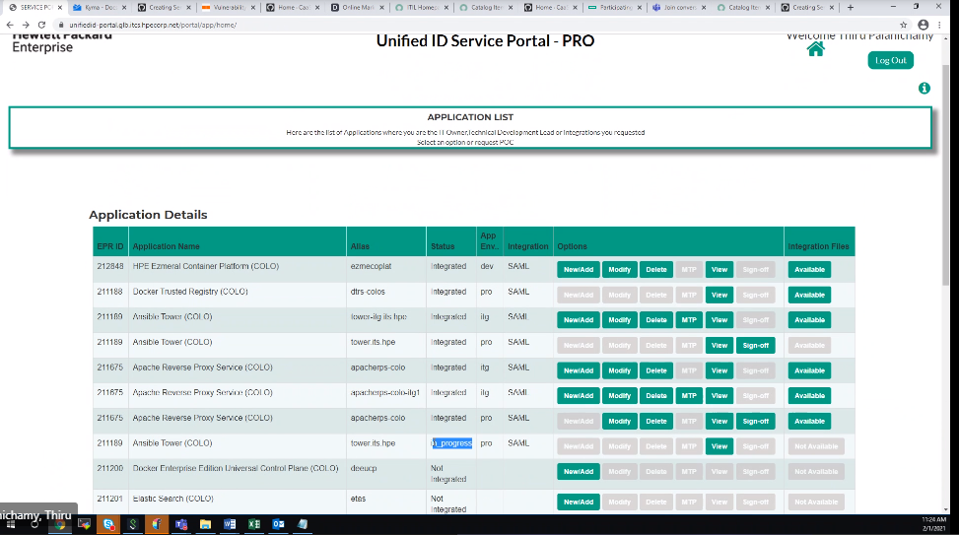

1. Click browse near signing cert and upload the latest SSL Public cert obtained

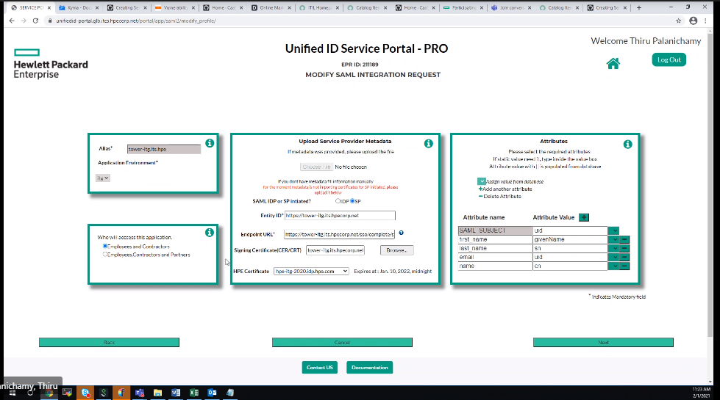

Note: It will take 10 mins for the update to reflect and status in progress when updated.